***1.Bug Title: “*Confirm password” field in the form displays password ,though password was initially hidden in the “Password” field**

***2.Severity :***

* **Medium**

***3.Reproducibility***

* **Always**

***4.Bug Type/Category***

* **UI**

***5.Steps to Reproduce***

* **Go to** [**https://qa-assessment.pages.dev/**](https://qa-assessment.pages.dev/)
* **Enter a password**
* **Confirm password**

***6.Expected Results***

* **Confirm password text input is supposed to be hidden**

***7.Actual Results***

* **Password entered in confirm password field not hidden**

***8.Screenshot/screenrecord link of bug***

**-screenShot**

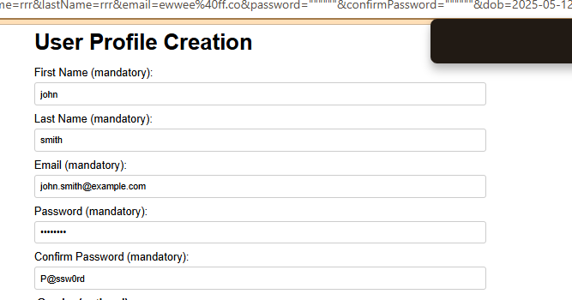

***9.Device Information***

**- Occurs on all Devices**

**-Connection type and speed: Mobile data / 17Mbps**